


Your first choice to turn

off bladder leakage immediately.
Providing the control and freedom women deserve! 1

Provides the short and long term conservative option for stress urinary incontinence Extensive clinical data and new clinical programme
Rapid life changing results

Contrelle Activgard®

Provides the immediate answer to stress urinary incontinence
- Majority of women don’t seek help as don’t believe there’s a solution
- Women stop exercise and change lifestyle to avoid triggers
- Pelvic ﬂoor training first line recommendation…though challenge for large % of women
New UK NICE guidelines support use of vaginal devices as part of conservative therapy approach. ²

Designed to stop leakage immediately


























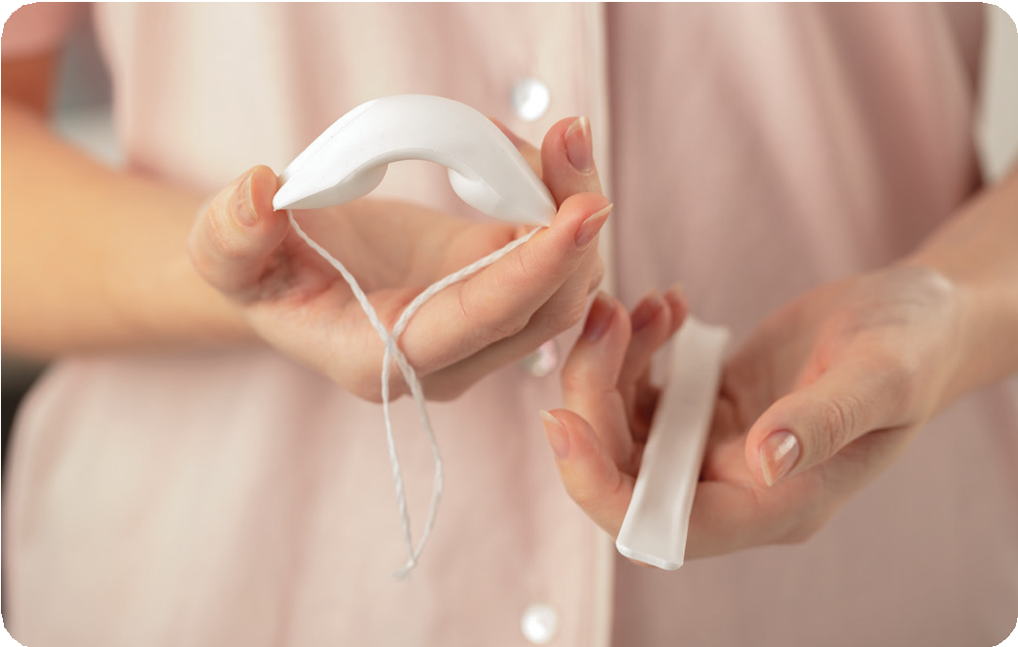
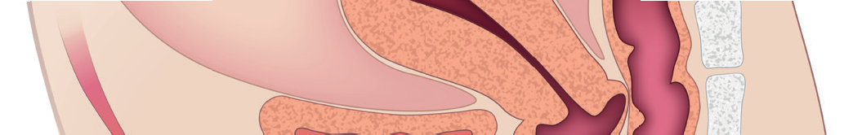



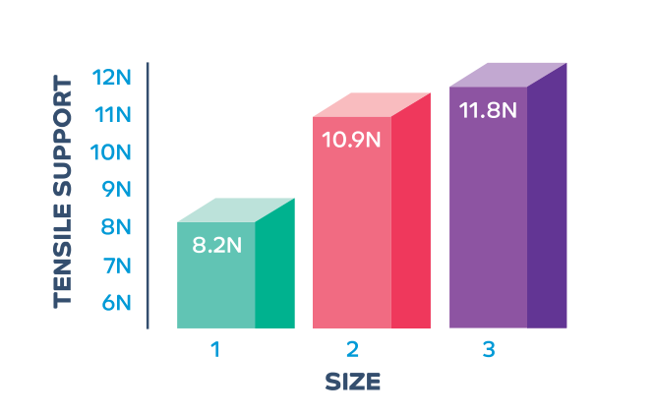
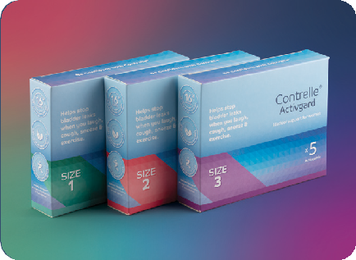







Cushion soft biocompatible foam matrix

Winged arch design with concave sections

Novel design works actively with body delivering multiple modes of action

3 sizes for most comfortable fit

Use for 16 hours a day or just when exercising

No pH changes or affect on vaginal ﬂora ⁵

Optimises comfort, support and efficacy

Ensures stability when positioned even during strenuous exercise

- Supports the bladder neck ³
- Helps reposition and improve bladder angle ^{3,4}
- Provides gentle pressure to the top of the urethra ⁴
- Reduces bladder mobility ⁶
- Targets the underlying condition

Ensures broad applicability to all patients

Hygienic and Disposable
Exercise, dance, live a normal life without fear or anxiety of leaking
Self administered, home use, convenient, saves professional time

Immediate results, can be used in long term ⁶
Contrelle® Activgard Device

Contrelle® Activgard in position

Different levels of support provided by the different sizes.

Proven Clinical Success – Most researched device in class

7 published trials showing clinically significant results

Demonstrates support and stabilisation of bladder neck ⁴
Reduction in bladder and urethral mobility ⁴
2/3rds of women subjectively dry ^{5,6}
Up to 95% women stop leakage or significant reduction ^{5,6}
70%+ reduction in pad test leakage volume ^{3,4,5,7}
Major quality of life improvements – 60% of women more physically active ¹

12 month follow up data shows improvement in condition without device
Proven efficacy, drug free conservative treatment
New clinical programme following successful pilot ⁸

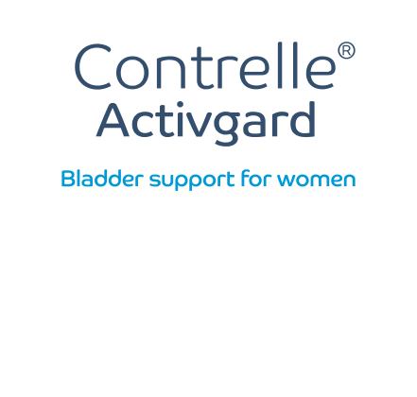
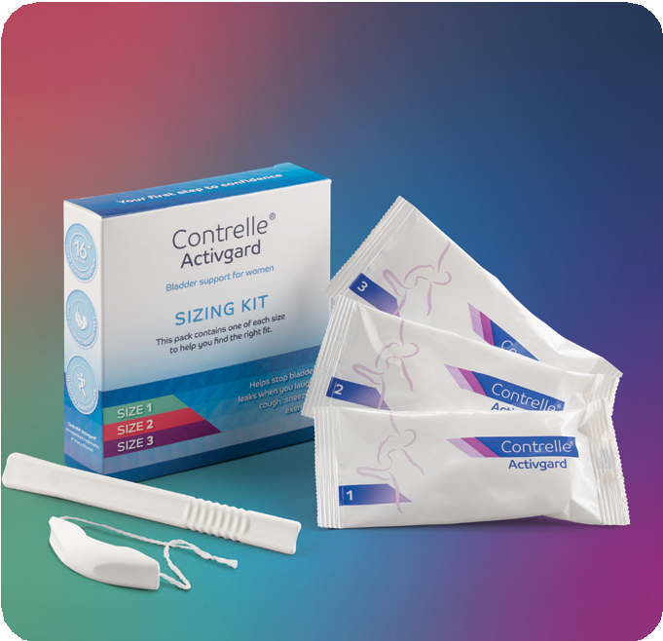


“Contrelle is not just a device but
a platform for education so women can now put pelvic health first”

CE marked Class IIa medical device UK manufactured

REFERENCES: 1. Effect of a Vaginal Device on Quality of Life With Urinary Stress Incontinence Pia Sander, MD, Hans Thyssen, MD, Gunnar Lose, MD, DMSc AND Jens Thorup Andersen MD, DMSc Obstetrics & Gynaecology, Vol 93, 3 March 1999 2. NICE guideline [NG210] Dec 2021 1.6.21 3. Treatment of female stress urinary incontinence with a new anatomically shaped vaginal device (Conveen Continence Guard) I Hahn & I. Milsom British Journal of Urology, Volume 77 Number 5 Pages 711-715 4. Effect of vaginal devices on bladder neck mobility in stress incontinent women Lone Mouritsen, Departmentof Obstretrics and Gynecology, Gentofte Hospital, University of Copenhagen, Denmark Acta Obstetricia et Gynecologica Scandinavica 2001 80: 428-431 5. New disposable vaginal device (continence guard) in the treatment of female stress incontinence: Design, efficacy and short term safety Hans Thyssen and Gunnar Lose, Glostrup County Hospital, University of Copenhagen, Denmark Acta Obstetricia et Gynecologica Scandinavica 1996: 75 -173 6. Long Term Efficacy and Safety of a Disposable Vaginal Device (Continence Guard) in the Treatment of Female Stress Incontinence H. H Thyssen and G. Lose, Glostrup County Hospital, University of Copenhagen, Denmark International Urogynaecology Journal 1997 8:130-133 7. A new intravaginal device for stress incontinence in women H Thyssen, J. Bidemead, g Lose, K Moller Bek, P Dwyer, L Cardozo Glostrup County Hospital, University of Copenhagen, Denmark, Kings College Hospital London, Skejby Hospital Denmark, The Royal Women’s Hospital Melbourne Australia BJU Int. 2001 Dec 88:889-92 8. A Vaginal Device (Continence Guard) in the Management of Urge Incontinence in women H.Thyssen, P. Sander, G.Lose Int. Urogynaecology Journal 1999 10:219-222

Visit our website

www.contrelle.com
or call our Product Specialists on

0330 229 2161

MKT 003 -01

